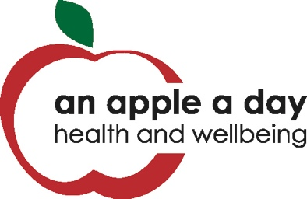

/Users/Sarah/Library/Containers/com.microsoft.Outlook/Data/Library/Caches/Signatures/signature_1560314401

**Health and Wellbeing Pilot**

Red Kite is delighted to be partnering with An Apple A Day CIC to bring a post-COVID pilot wellbeing programme to patients In South Powys. This service offers a motivational self-management programme, designed to support patients to return to normal after COVID- 19 through referral from your GP practice.

**About Apple A Day**

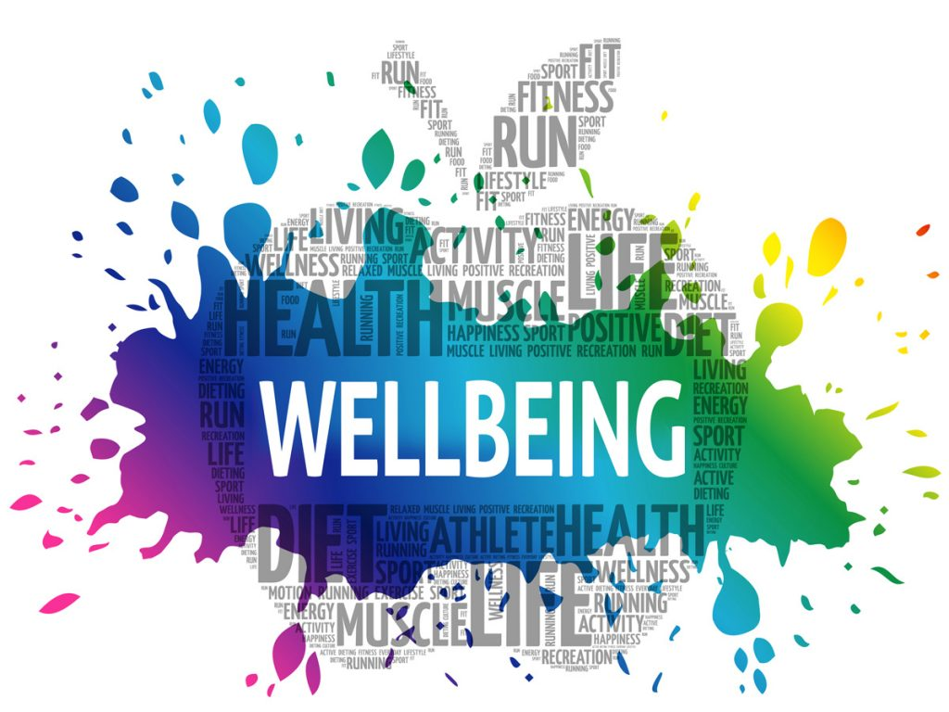

An Apple A Day (Health and Wellbeing) CIC, delivers interactive and lively health and wellbeing workshops to organisations and groups across the UK.

A Disability Confident Employer, with a dedicated and passionate team of Facilitators and Support Staff make up the Apple A Day Team. All the team at An Apple a Day live well with health conditions themselves.

Patients will learn self-management strategies from an experienced and dedicated team who all live well with health conditions, learn positive coping mechanisms and manage their wellbeing to increase their quality of life.

The programme will equip patients with the tools, knowledge and self-efficacy to improve their emotional wellbeing, consider choices and changes together with participation in a range of relaxation exercises. It is hoped that patients will make choices to enable them to move forward in their lives.

Patients who wish to participate in the programame will be contacted to attend a twice weekly online group session, for one hour, for 6 weeks. Alongside the online group sessions, patients will receive 121 support (a phone call once a week, for 6 weeks) where barriers will be explored and patients will be encouraged to commit to a weekly action that improves health and wellbeing.